

Student Performance Insights Dashboard

Week 1 – Data Understanding & Import
Data Miners


Contents
Project Overview 2
Column Data Types 2
Data Preview 3
Categorical Columns Summary 3
Numerical Columns Summary 4
Missing Values Check 5
Observations / Notes 5


Project Overview
The goal of this project is to analyze student performance data to uncover trends and insights, with the aim of building an interactive dashboard.
This week’s objective includes understanding data types, inspecting the dataset structure, and importing the data into MySQL Workbench and Databricks.

Dataset Information:
- Source: Kaggle: Students Performance in Exams
- Schema Name (MySQL): side_project
- Table Name: students_performance
- Rows:1000
- Columns: 8

Column Data Types

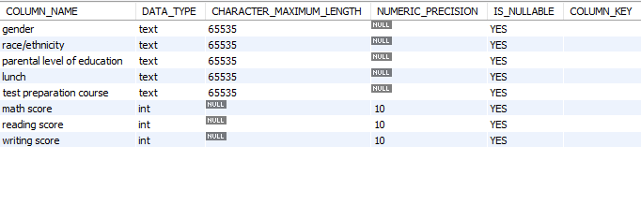

The schema overview shows that all categorical fields (gender, race/ethnicity, parental level of education, lunch, and test preparation course) are stored as TEXT types, each allowing NULL values. The score fields (math, reading, and writing) are defined as INT with standard numeric precision and allow NULLs. No primary keys or default values are set, indicating a simple, flat dataset structure imported directly from the source.

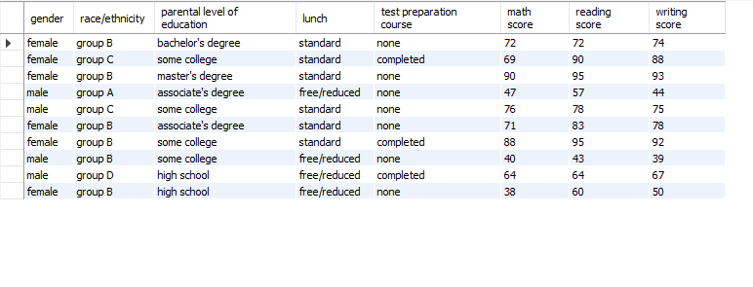
Data Preview
This table displays a sample of student performance records, combining demographic attributes with exam scores. Each row represents one student and includes fields for gender, race/ethnicity, parental education level, lunch type, and whether a test preparation course was completed. Academic performance is captured through three numerical columns: math, reading, and writing scores (ranging from 0 to 100). This preview illustrates the dataset’s structure, five categorical variables and three numerical variables and highlights potential relationships, such as higher scores among students who completed test preparation courses and differences linked to lunch type or parental education.

Categorical Columns Summary
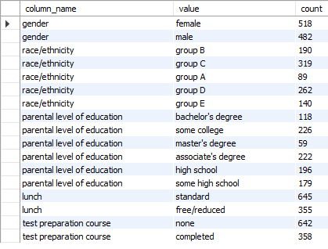

The table shows the frequency of values for each categorical column in the dataset. There are five main categories:
- Gender: 518 female, 482 male (almost balanced).
- Race/Ethnicity: Group C is the largest (319), followed by Group D (262), Group B (190), Group E (140), and Group A (89).
- Parental Education: Most common levels are “some college” (226) and “associate’s degree” (222), while “master’s degree” is least common (59).
- Lunch Type: 645 students have standard lunch; 355 have free/reduced lunch.
- Test Preparation: 642 students did not complete the course; 358 completed it.
This summary highlights the distribution of demographic and contextual factors that can influence performance analysis.

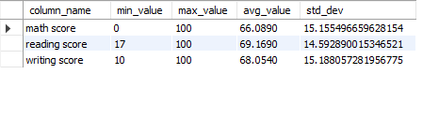
Numerical Columns Summary

This table shows key statistics for the three numerical columns: math, reading, and writing scores. Each subject has a score range from low to high, along with average performance and variability:
- Math Score: Min0, max100, average 66.09, standard deviation ~15.16.
- Reading Score: Min17, max100, average 69.17, standard deviation ~14.59.
- Writing Score: Min10, max100, average 68.05, standard deviation ~15.19.
Overall, students perform slightly better in reading and writing than in math, and all subjects show similar variability (around 15 points), indicating moderate spread in scores.

Missing Values Check
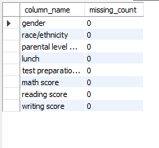

The table shows that there are no missing values across all columns in the dataset. Each field, gender, race/ethnicity, parental level of education, lunch, test preparation course, math score, reading score, and writing score, has a missing count of 0. This means the dataset is complete and ready for analysis without requiring data cleaning or imputation.

Observations / Notes
Data Completeness: The dataset has 1,000 rows and 8 columns with no missing values, so it’s ready for analysis.
Data Structure:
- 5 categorical columns: gender, race/ethnicity, parental education, lunch, test preparation.
- 3 numerical columns: math, reading, and writing scores.
This mix supports demographic and performance analysis.
Categorical Overview:
- Gender is almost balanced.
- Race/ethnicity is diverse, with Groups C and D most common.
- Parental education varies; “some college” and “associate’s degree” are most frequent.
- Lunch type and test prep completion may influence performance.
Performance Trends:
- Average scores: Math (66), Reading (69), Writing (68).
- Reading and writing slightly outperform math.
- Variability is moderate across all subjects.
Insights for Dashboard:
- Compare scores by test prep and lunch type.
- Check links between parental education and performance.
- Analyze patterns by race/ethnicity and gender.
Technical Notes:
- Schema allows NULL and lacks a primary key; adding an ID and constraints is recommended.
- Data is clean and ready for visualization and modelling.

